Part B: C++ ODE Solver using Object-Oriented Programming (OOP)
Q1) To ensure solver runs, ensure all source files (.cpp and .h files) are in a single directory with no sub-directories. The code is designed to be compiled and debugged on a Linux system using the GCC compiler with C++17 standards.
Run the following command in an integrated terminal to compile the code without any error or warnings [1]:
g++ -Wall -Wpedantic -std=c++17 *.cpp -o ODE_solver
./ODE_solver
This command compiles all .cpp files in the current directory (main.cpp, Solver.cpp, System.cpp, Integrator.cpp) and links them into an executable called ODE_solver. The prerequisite is a valid configuration file named parameters.txt in the same directory as the executable. Upon completion, console will confirm initialisation and completion, and results written to output.txt.
The parameters.txt file must contain exactly 3 lines of space separated numeric values. Line 1 should contain the simulation settings in this format: [ODE] [Scheme] [T] [dt], where ODE is an integer that selects the ODE system to be analysed (see Table 1 for the selection), Scheme an integer that picks the integration method (see Table 2 for options), T is a double containing total time, and dt is a double with the constant step size. Line 2 contains the system parameters in this format: [param1] [param2] … [paramM], where these parameters are the physical constraints of the chosen system and depend entirely upon the ODE picked. Line 3 contains the initial conditions of the system in the format: [ic0] [ic1] … [icN], where these are the starting values at t = 0 and the dimension depends on the ODE (see Table 1 for initial conditions for selected ODEs.
ID | System Name | Parameters (in order) | Dimension (in order)
1 | Predator-Prey | (x, y) – (prey, predator) | α, β, γ, δ
2 | SIR Epidemic (with Vital Dynamics) | (S, I, R) – (susceptible, infected, recovered) | β, γ, µ
3 | Van der Pol Oscillator | (x, y) – (position, velocity) | µ
4 | Lorenz Attractor | (x, y, z) – (convection, temperature difference, distortion) | σ, ρ, β
5 | Two-Compartment Diffusion | (C1, C2) – (concentration 1, concentration 2) | k
Table 1: Supported ODE systems.
ID | Scheme Name
1 | Forward Euler
2 | Runge-Kutta 4
Table 2: Supported integration schemes.
Q2) The solver is designed using modular Object-Oriented Programming (OOP) architecture that separates definition and implementation of systems and the mathematical ODE problems from the numerical methods that solve them. Three core components were utilised: the System class (contains libraries of ODEs and information on them), the Integrator class (how we’re going to solve the ODE) and the Solver class (manages what and how to solve the problem).
I used the concept of inheritance to define an interface for all the ODEs and integration schemes. First, I defined 2 abstract classes, System and Integrator. System defines the interface for any ODE problem (e.g. gets dimensions, computes derivatives, get number of parameters etc.) while Integrator defines the interface for time-stepping (what integration scheme used to calculate next step). Inheritance comes in with the derived classes where specific implementations inherit from these bases [2]. For example, PredatorPreySystem and LorenzAttractorSystem inherit from System, while ForwardEuler and RungeKutta4 inherit from Integrator. The benefit of this is it creates a generic structure where the Solver does not need to know the specific details of a model (e.g., whether it is SIR or Van der Pol) to solve it. It only interacts with the generic System interface.
The second concept used is polymorphism, the core mechanism allowing the solver to switch between different ODEs and time schemes at runtime [2]. The base classes declare pure virtual functions, such as virtual void computeDerivatives(...) = 0. This forces every derived class (like SIREpidemicSystem) to provide its own implementation of the equations. The Solver class holds pointers to the base types: std::unique_ptr<System> and std::unique_ptr<Integrator>. When solver.run() executes, it calls integrator->step(...). Because step is virtual, the program determines at runtime whether to execute the code for ForwardEuler or RungeKutta4. The benefit of this is it offers high extensibility meaning if I need to add another ODE I simply create a new class that inherits from System, the integration scheme and Solver loop remain entirely unchanged.
The project strictly separates interface from implementation by placing class declarations and prototypes in header files (e.g., System.h) while isolating the computational logic and mathematical formulas within source files (e.g., System.cpp, Integrator.cpp). This structure encapsulates complexity, allowing the solver to interact with abstract definitions without exposing internal details, which ultimately improves code readability and compilation efficiency by ensuring that changes to the logic do not necessitate recompiling the entire system.

Q3) To validate the accuracy and robustness of the C++ ODE solver, the implementation was benchmarked against MATLAB’s ode45 solver, a standard and highly accurate variable-step Runge-Kutta method [3]. The validation process involved solving two distinct ODE systems (one linear and the other non-linear): Two-Compartment Diffusion model (data encased in parameters1.txt) and Predator-Prey model (data encased in parameters2.txt) using both the C++ solver and MATLAB ode45 using identical initial conditions and time steps. Note, the input text file will require changing name to parameters.txt but both graphs in Fig. 1 and 3 can be replicated using the respective input text file.
The conditions for the two-compartment diffusion model used the Runge-Kutta 4 method, step size of 0.1, final time of 10, one parameter of 0.5 (for diffusion rate constant), and 15 and 5 for initial conditions respectively. Looking at the linear system (Fig. 1), the C++ output overlaps the MATLAB ode45 reference solution perfectly for both concentration variables (C1 and C2). The system correctly reaches an equilibrium state at approximately t = 5 s. The total absolute error was calculated by summing the difference between the benchmark to the C++ results at each data point shown in Fig. 2. The error can be seen remaining extremely low, maxing at around 3e-3 and generally decaying towards zero as the system reaches steady state.
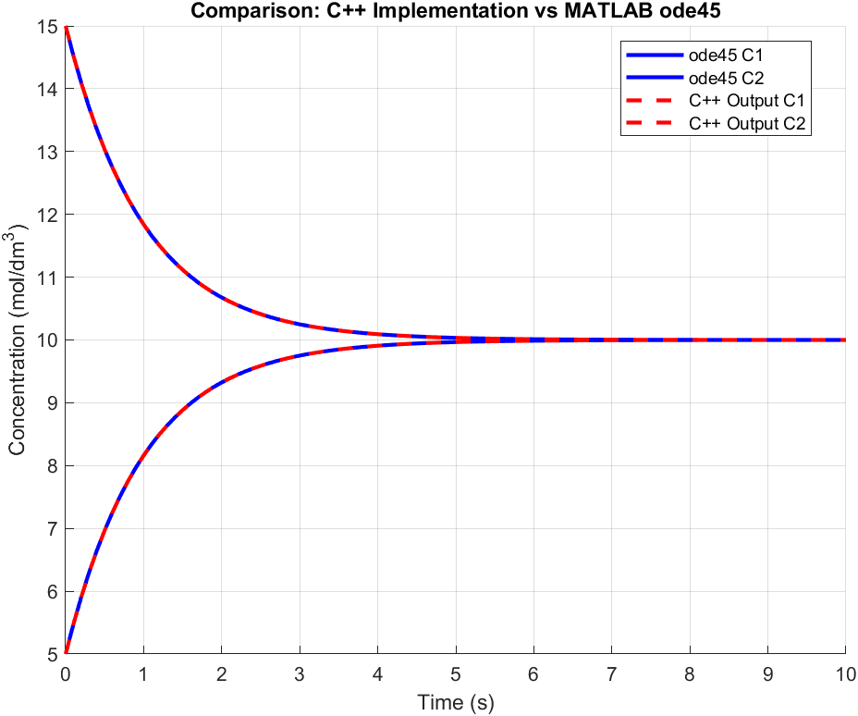
Figure 1: Two-compartment diffusion model with C++ solver vs ode45.
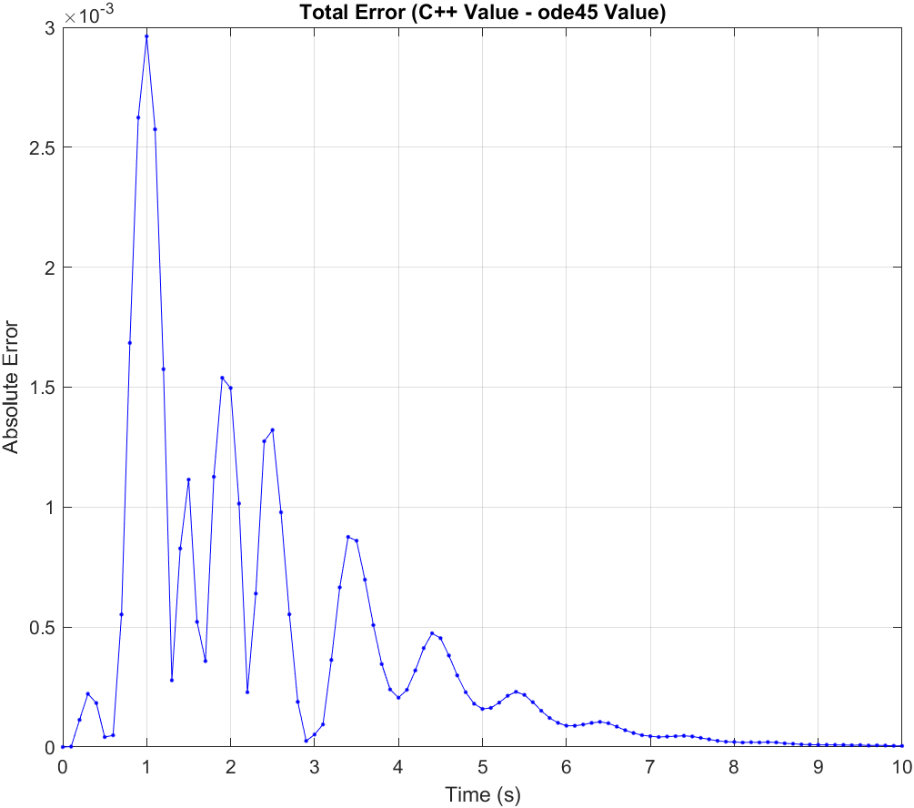
Figure 2: Two-compartment diffusion model total error for C++ solver vs ode45.
The conditions for the predator-prey model used the Runge-Kutta 4 method, step size of 0.1, final time of 50, four parameters in order: 1.1, 0.4, 0.4, 0.1; and 10 and 10 for initial conditions respectively. This was a more rigorous test of the C++ solver’s ability to handle non-linear and oscillatory behaviour [4]. Fig 3. illustrates the population dynamics of prey and predators over 50 seconds. The C++ implementation tracks the MATLAB ode45 reference (solid lines) with high precision. The solver successfully captures the phase lag between the predator and prey populations and maintains the correct amplitude for the peaks. The absolute error plot (Fig.4) for this system shows error spikes coinciding with the rapid changes in population size (high derivatives), which is expected in numerical integration. However, the maximum error is approximately 0.06 relative to a population peak of approximately 30, representing a negligible deviation and confirming the solver's stability over longer integration periods.
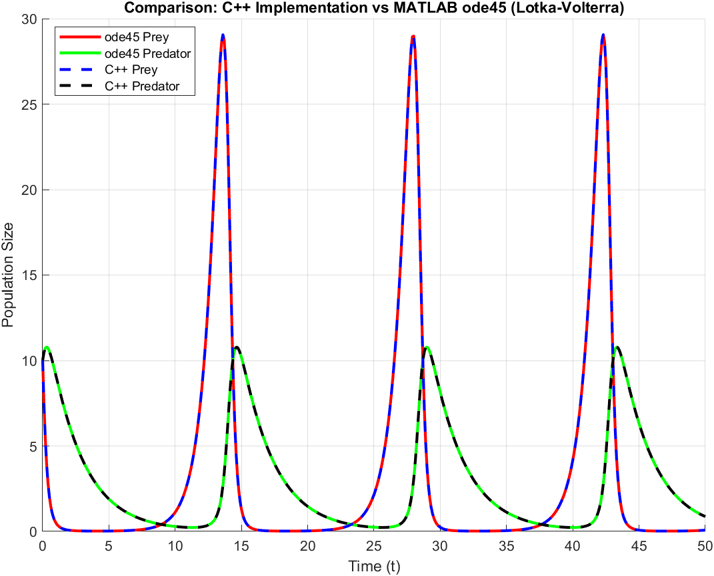
Figure 3: Predator-prey model with C++ solver vs ode45.
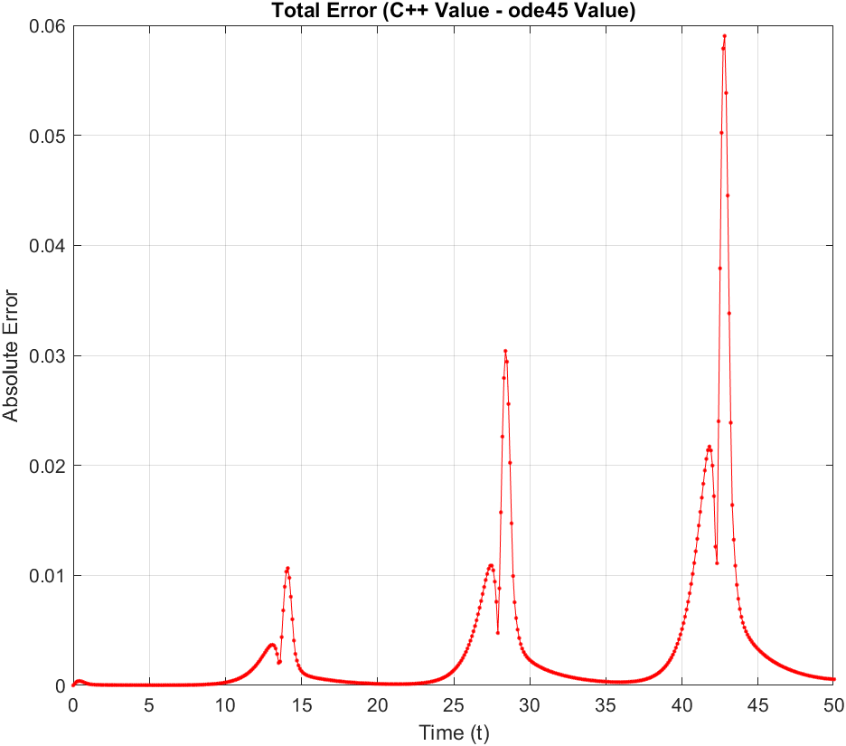
Figure 4: Predator-prey model total error for C++ solver vs ode45.

References:
[1] Imperial College London, Department of Aeronautics. AERO50003 Computing and Numerical Methods 2, Coursework. Imperial College London; 2025.
[2] Stroustrup B. The C++ Programming Language. 4th ed. Boston: Addison-Wesley; 2013.
[3] Shampine LF, Reichelt MW. The MATLAB ODE Suite. SIAM Journal on Scientific Computing. 1997;18(1):1-22.
[4] Strogatz SH. Nonlinear Dynamics and Chaos: With Applications to Physics, Biology, Chemistry, and Engineering. 2nd ed. Boulder: Westview Press; 2015.

